**Category type**

**1).Classification of unmanned aircraft systems in weight :**

The unmanned aircraft system shall, based on the maximum all-up weight including

payload, be classified as follows:

• Nano unmanned aircraft system: weighing less than or equal to 250 grams;

• Micro unmanned aircraft system: weighing more than 250 grams, but less

than or equal to Two kilograms;

• Small unmanned aircraft system: weighing more than Two kilograms, but

less than or equal to 25 kilograms;

• Medium unmanned aircraft system: weighing more than 25 kilograms, but

less than or equal to 150 kilograms • Large unmanned aircraft system: weighing more than 150 kilograms.

**2).DRONE APPLICATION TYPES ACCORDING TO TYPES OF INDUSTRY :**

Drone technology has evolved and thrived in recent years, from technically staffing critical military regions to enticing enthusiasts all over the world. Individuals, businesses, and governments have realized that drones have a variety of valuable qualities, including:

Aerial photography for journalism and film

Express shipping and delivery

Gathering information or supplying essentials for disaster management

Thermal sensor drones for search and rescue operations

Geographic mapping of inaccessible terrain and locations

Building safety inspections

Precision crop monitoring

Unmanned cargo transport

Law enforcement and border control surveillance

Storm tracking and forecasting hurricanes and tornadoes

Development of hundreds of more uses of drones are underway due to the multiple investments pouring into this promising industry everyday

Military Drone Technology

The military is probably the oldest, most well-known, and most contentious application of drones. In the early 1940s, the British and American forces began utilizing extremely crude kinds of drones to spy on the Axis powers. Drones today are far more advanced than UAVs of the past, including thermal imaging, laser range finders, and even airstrike instruments. The MQ-9 Reaper is a well-known military drone. The aircraft is 36 feet long, can travel 50,000 feet in the air undetected, and is outfitted with a variety of missiles and intelligence gathering systems.

Delivery Drone Technology

Delivery drones are typically unmanned aerial vehicles (UAVs) that bring meals, packages, or commodities to your front door. These flying vehicles are known as “last mile” delivery drones because they make deliveries from nearby retailers or warehouses. Instead of depending on delivery drivers with inefficient trucks, retailers and grocery chains throughout the country are turning to drones as a more effective delivery alternative. These drones can deliver 55 pounds of items to your front door without requiring you to leave the house. Amazon, Walmart, Google, FedEx, UPS, and many other major corporations are all testing various types of delivery drones.

Drone for Emergency Public Rescue

Due to the scale or severity of the disaster, it is not always safe to send humans into a rescue situation. This is where drones come into play. In the event of a capsized boat or a drowning person, officials can deploy an Autonomous Underwater Vehicle (AUV) to assist in the rescue.

Drone for Agriculture

Drones have also shown to be advantageous to the agriculture business, providing farmers with a variety of options for optimizing their crops to maximize efficiency and minimize physical strain. UAVs make field surveys, sowing across fields, tracking livestock, and predicting crop yields easier while saving agriculture workers important time.

Drone for Outer Space

NASA and the United States Air Force have been testing unmanned aircraft designed for space flight. The Air Force’s ultra-secretive X-37B UAV looks like a small space shuttle. It has been quietly circling the Earth for the past two years, setting a record for the longest unmanned aircraft flight (781 days and counting). Although the Air Force has been ambiguous, it has stated that “the primary objectives of the X-37B are twofold: reusable spacecraft technologies for America’s future in space and operating experiments that can be returned to, and examined on Earth.” When it comes to the future of space exploration and innovation, it appears that drones have been prioritized.

Drone for Wildlife and Historical Conservation

Drones are a less expensive and more efficient way to conserve wildlife. With humans on the ground, tracking wildlife populations is practically difficult. The ability to track travelling groups of animals, ranging from Orangutans in Borneo to Bison on the Great Plains, allows wildlife conservationists to gain a better understanding of the health of their species and ecosystems. Conservation drones are also useful in the fight against poaching in Asia and Africa.

Drones are also being employed in global forestry projects. These drones scan the forest floors of burned-out forests, dropping seed vessels containing seeds, fertilizers, and nutrients that will help a tree rise from the ashes. Since the early 1990s, there has been around 300 million acres of deforested land. What would take humans approximately 300 years to reforest can be performed more efficiently with seed-planting drone technology.

Drone in Medicine

How do you get medical supplies to people who live in remote areas? What device could you utilize to transport organs to transplant patients? Drones can address both of those questions. Unmanned aerial vehicles are now being utilized to carry emergency medical supplies and goods to remote villages in Alaska. Instead of depending on dog sleds, snowmobiles, or ambulances that can’t manage the snow, Alaskans are turning to drones to get life-saving medical supplies delivered promptly.

Drones are also being used to transport donated organs to transplant recipients. A kidney was recently moved from one hospital in Maryland to another in under five minutes using a specially designed drone. This has the potential to reduce the painfully sluggish rate at which donations typically arrive (if they arrive at all). Organs are typically supplied through chartered or commercial flights. Delays and failures in judgement create dangerous two-hour or longer delays for 4% of all organ deliveries. Drones can significantly reduce time while also providing a safer and more secure means of organ transportation.

Drone for 3D Modeling

LiDAR drones are equipped with LiDAR sensors, which survey landscapes and collect detailed data that can be used to create 3D models. Drones with LiDAR technology can provide significantly more accurate data than drones without the technology. Aside from making it easier for drones to navigate varied surfaces, LiDAR allows them to locate targets in search and rescue missions, evaluate crops in agriculture, and many other things.

Drone for Photography

Drones have been a benefit to aerial photographers who employ UAVs to get expansive shots. Have you ever wanted to have a bird’s-eye view of your favorited city, beach, or building? There are drones designed exclusively for photography that offer a different perspective on some of your favorite locations.

**Types of drones :**

Drones come in different sizes, capabilities, and a wide variety of models, from recreational mini-drones to control and surveillance drones. Instead of throwing a bunch of new information at you, we decided to break things down into a few different drone categories.

**Types of drones according to wing types**

Here is a rundown of the four main types of drones according to wing type, their uses, their advantages, and disadvantages：

**Multi-rotor drones**

Multi-rotor drones, also known as rotary-wing, are the most widely used type of drones for recreational and professional use. Their small size and excellent control make multi-rotor drones the best choice for aerial photography

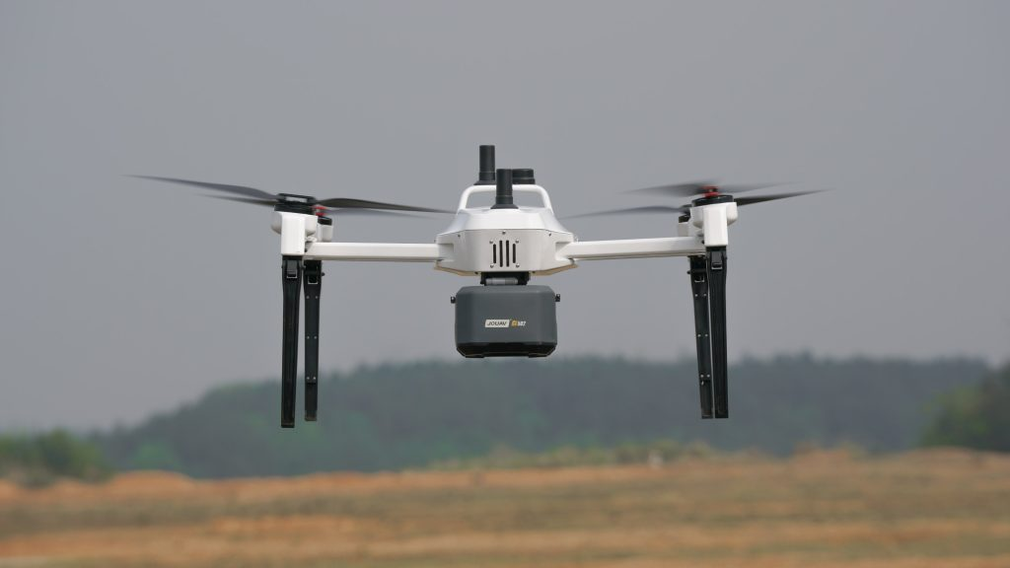

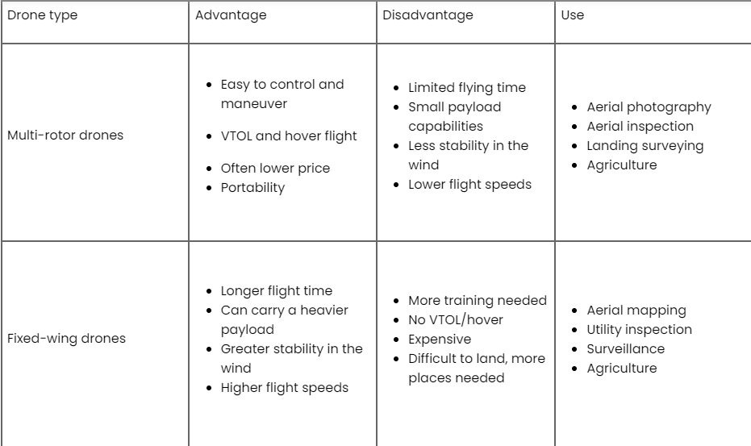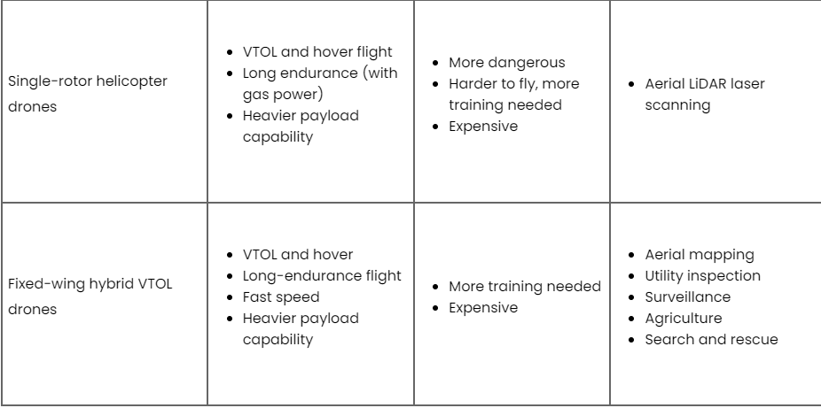

#### **Fixed-wing drones :**

[Fixed-wing drones](https://www.jouav.com/blog/fixed-wing-drone.html) are those capable of harnessing air and generating forces that allow them to stay in the air by taking advantage of their aerodynamics. They are similar in design or aesthetics to radio-controlled aircraft and are often used to map large areas due to their powerful autonomy. They take advantage of their aerodynamics and design to keep them afloat, which means they have a longer endurance and flight speed.

#### **Single-rotor helicopter drones:**

Powerful and durable, single-rotor drones look similar in construction and design to actual helicopters, with only one rotor to provide power, plus a tail to control direction and stability. Combining the advantages of tiny multi-rotor drones and single-rotor drones, they are better suited to carry larger payloads and fly more efficiently than multi-rotors. Single-rotor devices typically use gas engines rather than batteries, which greatly increases their flight time.

#### **Fixed-wing hybrid VTOL drones:**

As the latest drone technology to be introduced, fixed-wing hybrid VTOL drones refer to fixed-wing aircraft that have been modified to take off and land vertically. They combine the long-range and flight time of fixed-wing UAVs with the vertical takeoff capability of rotary-wing devices, eliminating the drawbacks of fixed-wing UAVs that require large spaces for takeoff and landing. They are designed for mapping, [power line inspection](https://www.jouav.com/industry/power-line-inspection), surveillance, agriculture, and rescue operations.

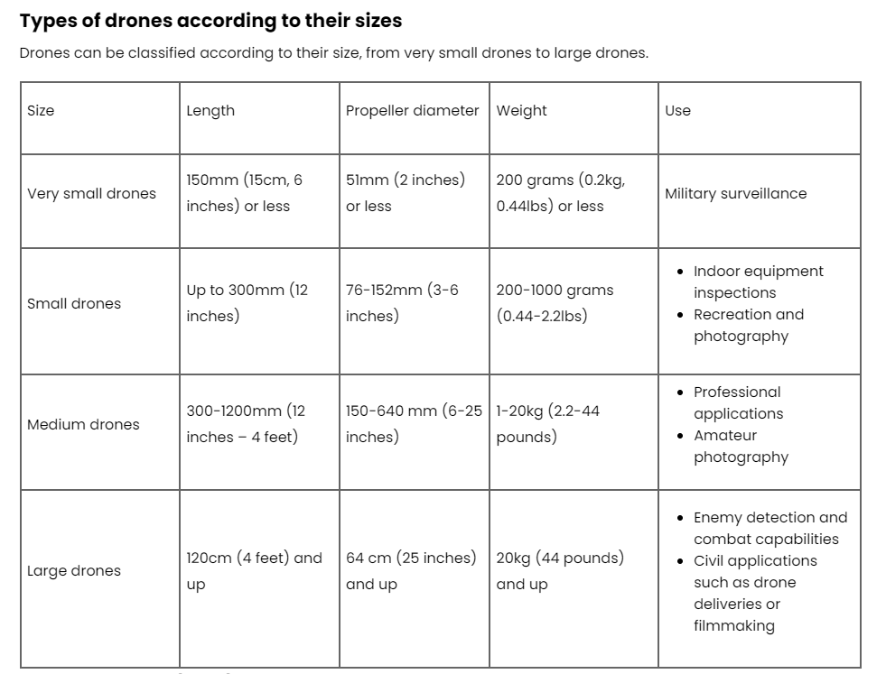

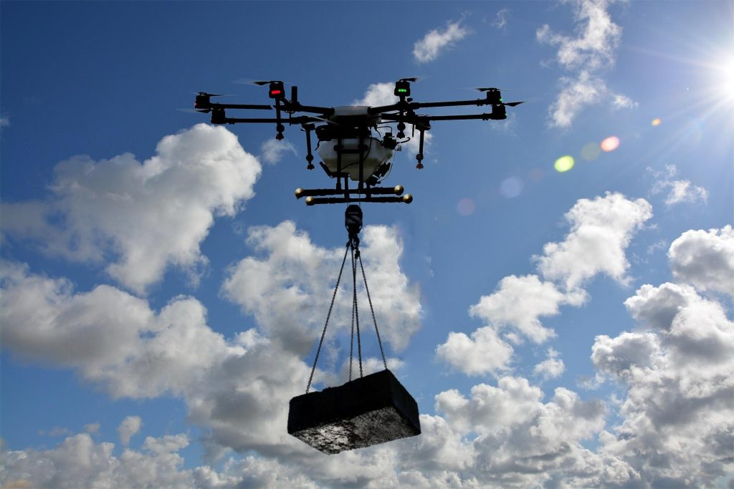

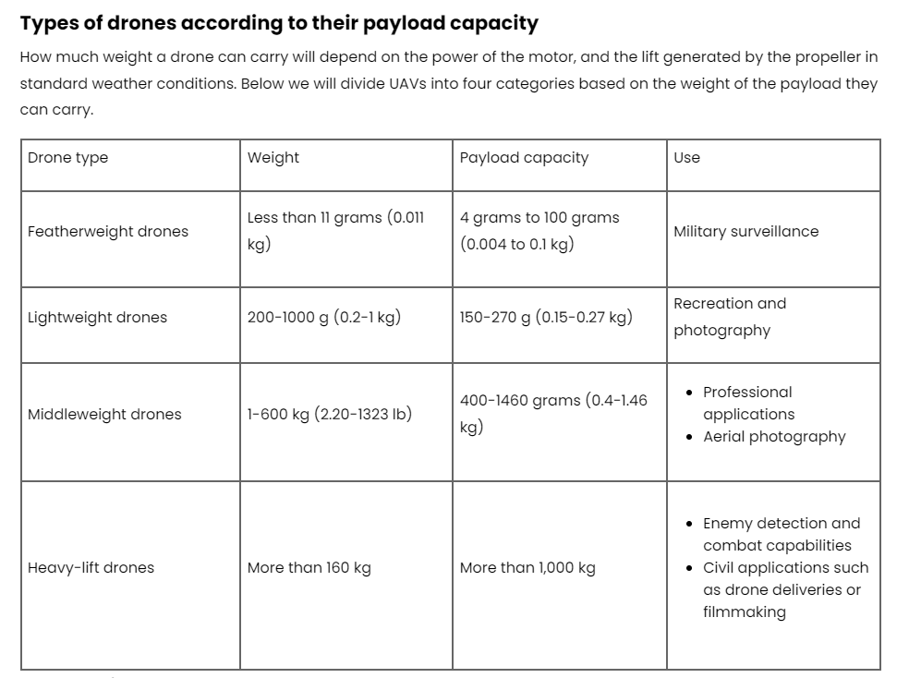

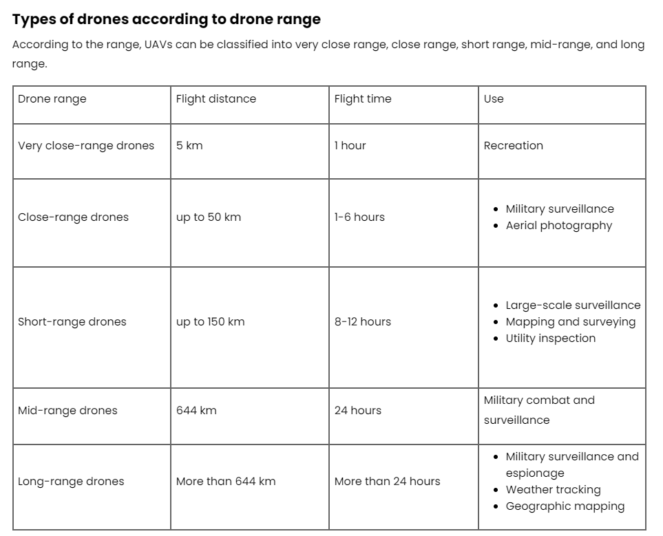

### Types of drones according to their power source :

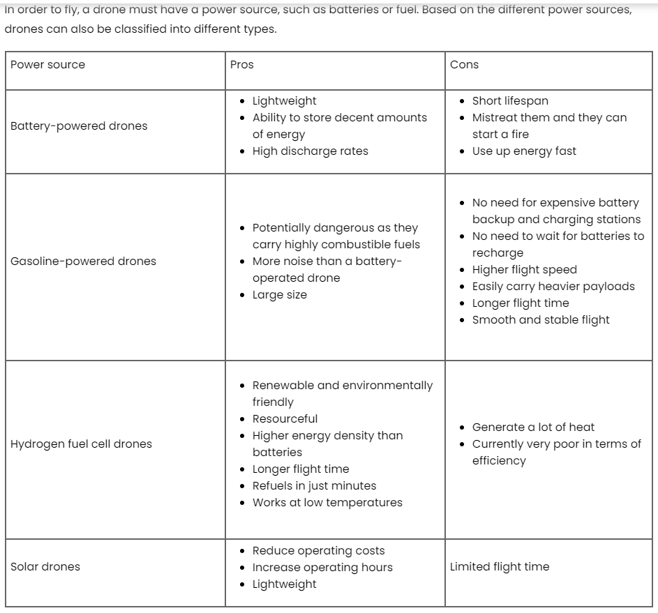

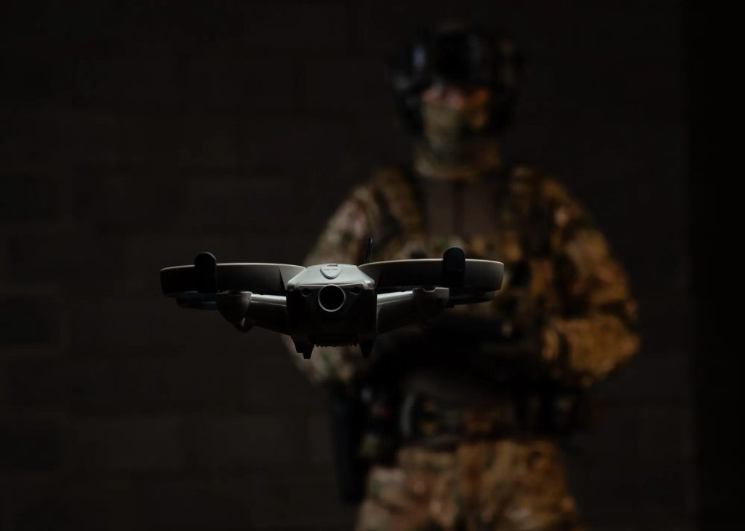

### Types of drones according to motors

According to the motor type, we can divide the drone types into brushed motor drones and brushless motor drones.

